1. Before running a spring boot app, it is good idea that we could use some kind of management console where Hazelcast instance is running.
2. Hazelcast has Management Center app which is downable.  
   Graphical user interface, text, application

   Description automatically generated
   1. Extract it.
   2. run startXXXx.bat.
   3. **Credentials**:
      1. **username**: jatin
      2. **password**: Hazelcast@135
   4. Graphical user interface, application

      Description automatically generated
3. Graphical user interface, text, application, chat or text message

   Description automatically generated
4. Let’s create a spring boot app.  
   
5. **Dependency**:  
   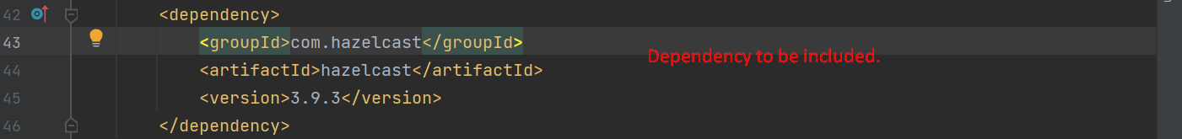
6. **Let’s define Hazelcast configuration**.